CURRICULUM VITE
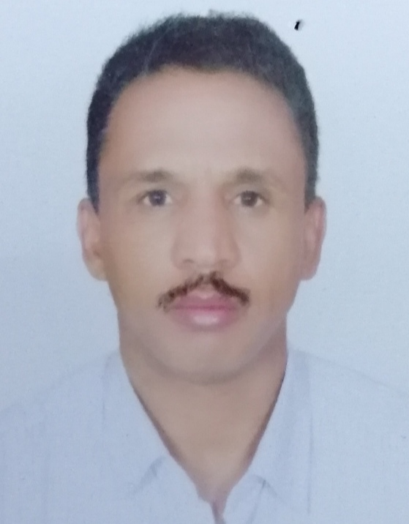
- NAME; Al Shareef Mohammed Al Shareef
- NATIONALITY; Sudanese
- GENDER; Male
- LANGUAGE; Arabic & English
- DATE & PLACE OF BIRTH, Kassala city, Sudan on 5th April 1975
- ADRESS, Dept. of surgery, university of Al Baha, KSA. Mobile; 0558951905
- E. Mail; shareefkassala75@gmail.com
QUALIFICATIONS

- Clinical M. D general surgery, Sudan Medical Specialization Board
[SMSB] in June 2012, [ P.O. Box 12892 Khartoum, Sudan]
- M.B.B.S, University of Khartoum, Faculty of Medicine. on 13th May 2002 [P.O, Box 102, Khartoum, Sudan]
- Master of medical education (Ongoing)& University of Gezira-Sudan.
- ESME (Essential Skills in Medical Education) certificate Barcelona, Spain 2016
REGISTRATION
- Sudan Medical Council, specialist registration on 2ed August 2012M
- Sudan Medical Council, permanent registration on 23ed March 2005M [P.O, Box 800, Sudan, Khartoum].
- Saudi commission for Health Specialties registration 23^{ed} June 2015
INTERSHIP TRAINING
- House man shift [ 30th November 2002 – 15th February 2004] Kassala Teaching Hospital, Sudan.
- Medical officer [ 1st May 2004- 1st May 2007M] Dept of general surgery & trauma, Kassala Teaching Hospital, Sudan.

RAGISTRAR SHIFT TRAINING [1st June 2008- 1st June 2012]
- General surgery 1, Kassala teaching hospital [ 15/6-15/12/2008M]
- Orthopedic surgery, Police hospital [16/12/2008- 16/6/2009M]
- General surgery2, Khartoum. T.H [20/6/2009- 20/12/2009M]
- Urology, Omdurman.T.H [ 23/12/2009- 23/6/2010M]
- Neurosurgery, Shaab. T.H, Khartoum [25/6-25/9/2010M]
- Pediatric surgery, Soba University hospital [ 28/9/2010 – 28/3/2011M]
- General surgery3, Khartoum teaching hospital [ 30/3- 30/9/2011M]
- Plastic surgery, Khartoum teaching hospital [1/10/2011-1/1/2012M]
- Anesthesia& Intensive care, Soba university Hospital [3/1-20/2/2012]
- Cardiothoracic surgery. Shaab.T. hospital [ 5/2- 5/5/2012M]
PAST APPOINTEMENTS
- Lecturer in general surgery, faculty of Medicine, Kassala University, Sudan. [5/8/2007 – 22/6/2012M]
- Assistant professor of general surgery, Kassala University, Sudan. [23/6/2012 – 1\12\2017]
- Head Department of Surgery, Kassala University [1/8/2013 – 20/9/2014M
- General Surgeon, Kassala teaching hospital since 1st of July 2012 up to 1st December 2018M
PRESENT APPOINTEMENT
- Assistant professor of general surgery Al Baha University – KSA.
- General surgeon university medical center AlBaha, Univ
TEACHING EXPERIENCES
- Teaching 4th * 5th & 6th years, medical students, faculty of Medicine, Kassala University
- Teaching 3ed & 4th years high nursing collage, Kassala university
- Examiner for final M.B.B.S surgical examination, in different schools of Medicine in Sudan.
- Assistant professor in faculty of medicine Al Baha university since January 2018
RESEARCH
- Burns in children, pattern management in Khartoum Teaching Hospital.
- Knowledge and attitudes about disc prolapse among population of AlBaha area-KSA
- Knowledge and awareness among population of AlBaha area-KSA about prostatic cancer

CONTINUAL MEDICAL EDUCATION
- Attend and participate in a workshop about Laparoscopy in pediatric surgery. Soba University Hospital, 23/1/2010
- Attend and participate in the third international conference on medical education, Sudan 31/10/2008- 3/11/2009
- Advance Trauma Life Support course [ATLS] S.M.S.B 3 ed - March 2012
- Participate in the 1st International conference in breast cancer, Khartoum, December 2012.
- A course in Medical Research & Breaking bad news & Counseling, S.M.S.B Jan 2011.
- Attend the AMEE (Association of Medical Education of Europe) conference 2016 Barcelona Spain
- ESME (Essential Skills in Medical Education) certificate Barcelona, Spain 2016)

REFERENCES
- Professor Moh. ElMekki [ ELRasheed], Professor of surgery university of Khartoum, Head of surgical specialization council S.M.S.B
- Professor Kamal Elzaki, Professor of surgery university of Khartoum. Khartoum, Sudan P.O.BOX 102
- Dr, Fath.Rahman.M.T. Associated professor of surgery, formerly head dept of surgery Kassala university mobile (+249912341984).
- Dr, Hani Baha ELdeen, associate professor of urology, Soba university hospital, Khartoum, P.O.BOX 8O8I
- Dr, Sami Eldidiri, Associated professor of surgery Gadarif University Sudan, mobile +249122039163

